**Annual Report on who receives Bonus:**

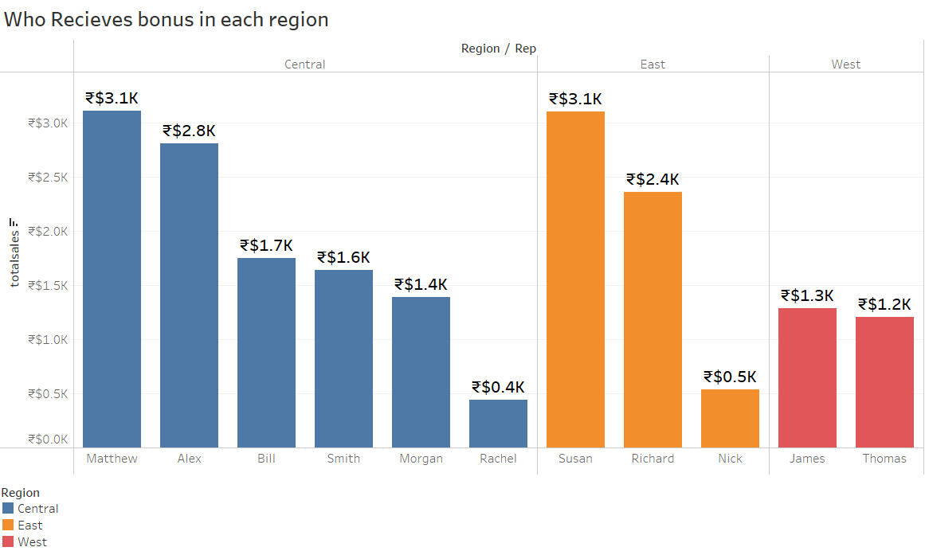

The above bar-chart depicts region-wise representatives who generated more revenue through sales. The representatives Matthew ,Susan and James receive bonuses.

Here,the revenue is total sales which is a calculated field obtained by

Total sales = [unit]*[unit price]